**HTML AND CSS CHEATSHEET**

**DOCUMENT STRUCTURE**

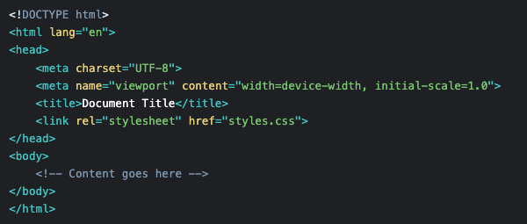

**COMMON ELEMENTS**

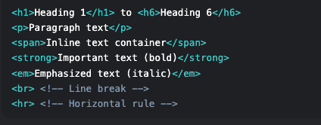

**LINK AND IMAGES**

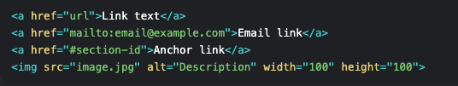

**LISTS**

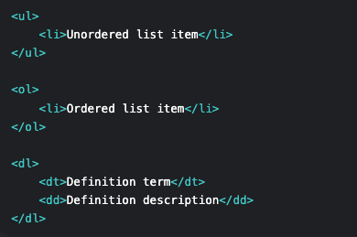

**TABLES**

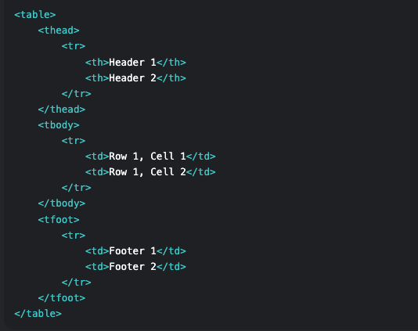

**FORMS**

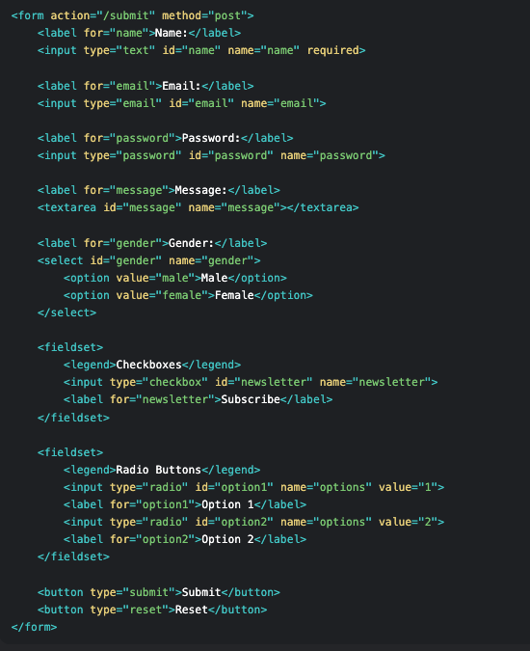

**SEMANTIC ELEMENTS**

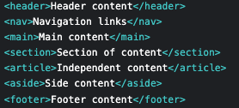

**MULTIMEDIA**

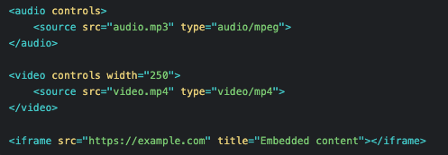

**CSS BASICS**

**CSS SYNTAX**

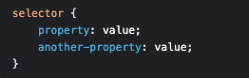

**BOX MODEL**

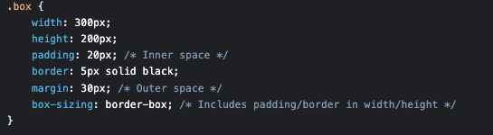

**SELECTORS**

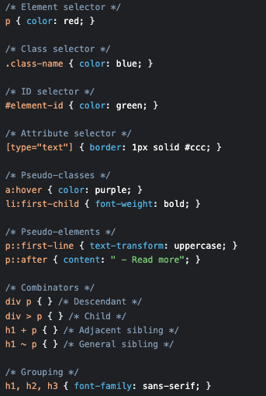

**DISPLAY AND POSITION**

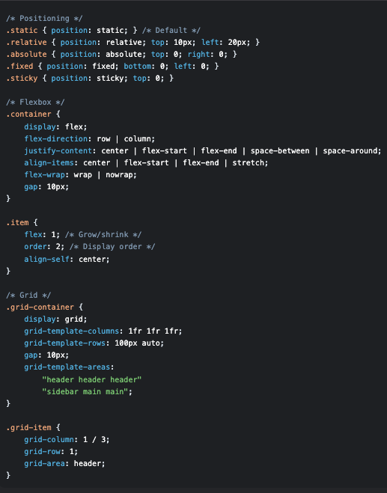

**COLORS & BACKGROUND**

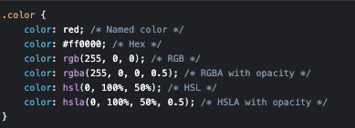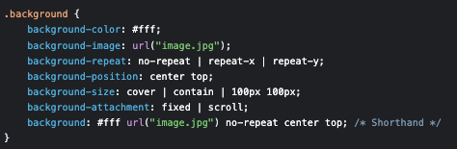

**TYPOGRAPHY**

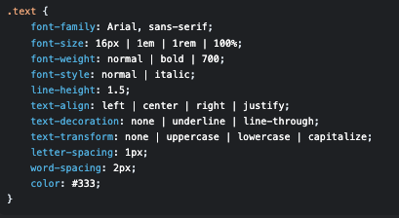

**BORDERS**

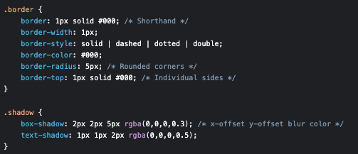

**TRANSITIONS & ANIMATIONS**

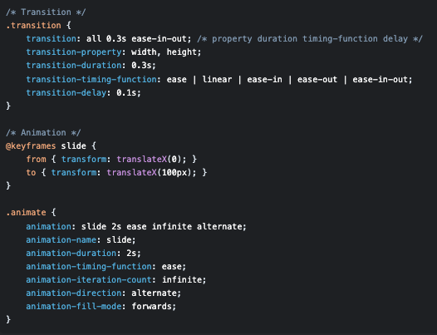

**TRANSFORM**

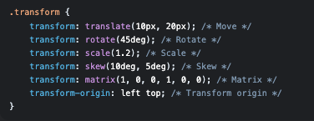

**RESPONSIVE DESIGN**

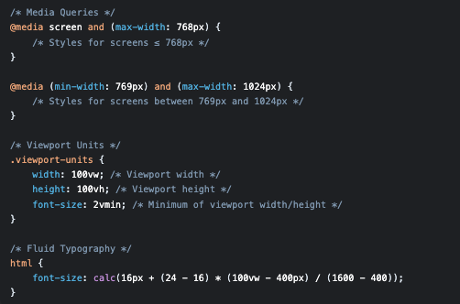

**CSS VARIABLES**

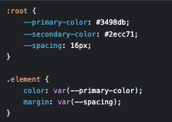

**FILTERS**

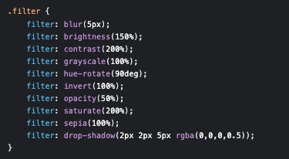

**CSS UNITS**

